When we first open the app and then go to the /about route, we will see the following page. It will inform us that we have no rotations. A button will be present to add a rotation.

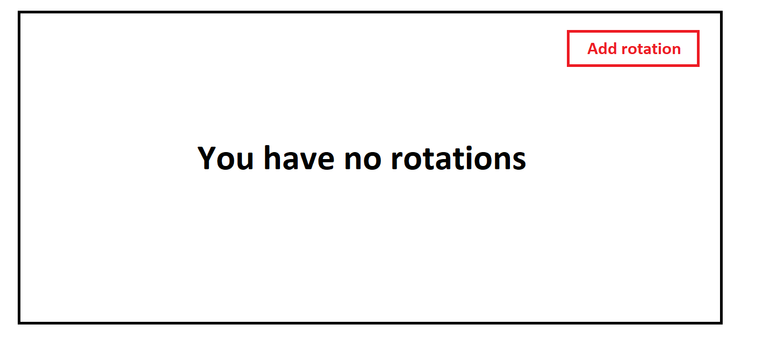

When we click on the “Add rotation” button, we will be greeted with a Bootstrap modal form asking us to add the rotation details.

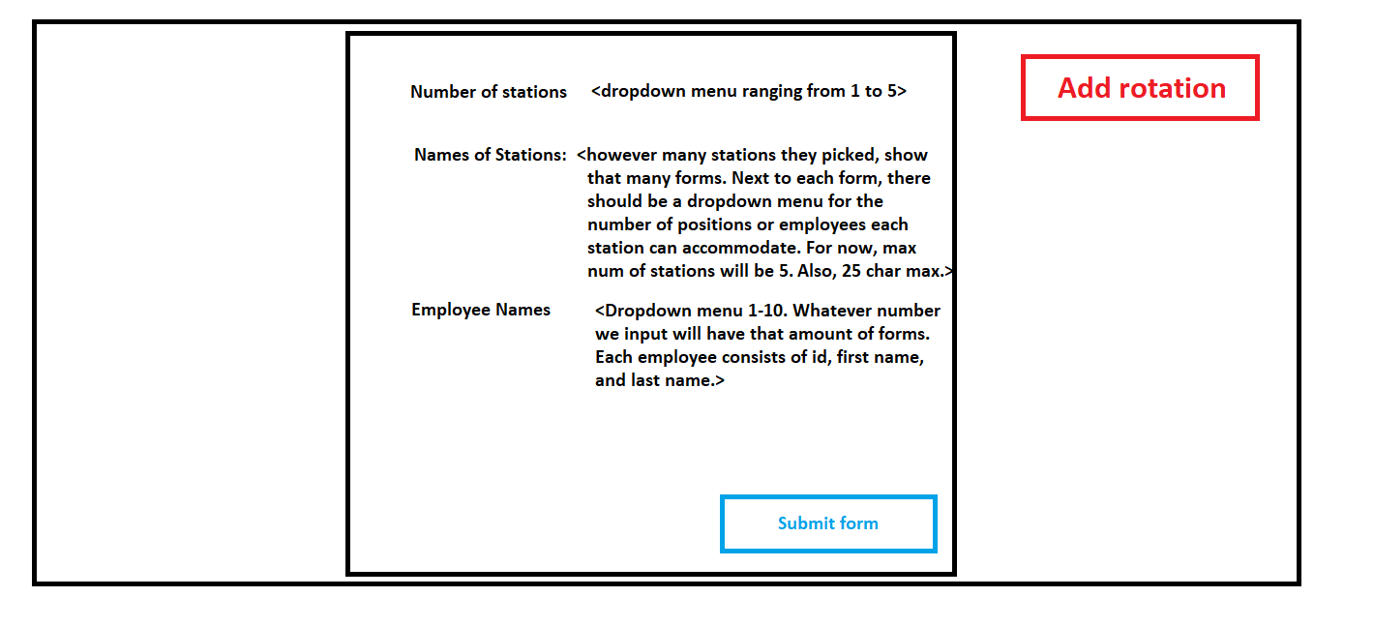

So an example of the above modal will be the following:

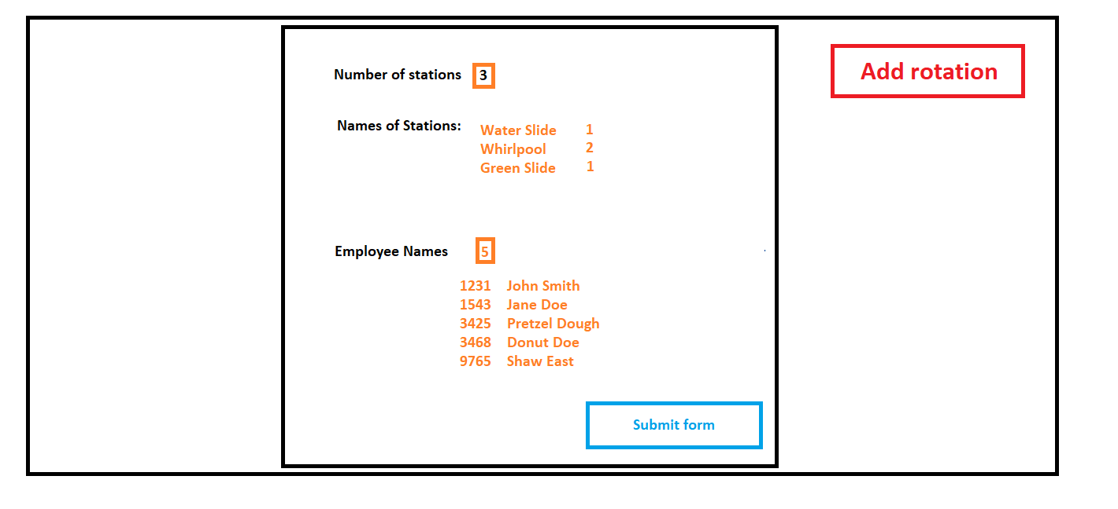

When we submit the above modal, we send a post request which stores this information in our database. Using the above example, we see that we have 3 stations with a total of 4 positions. We will populate these positions with the employee information that we provided. The order in which employees are populated within the given station doesn’t really matter. However, given that we have 5 employees, but only 4 stations, not all employees will have a position. Once we submit the above modal, we will get the following:

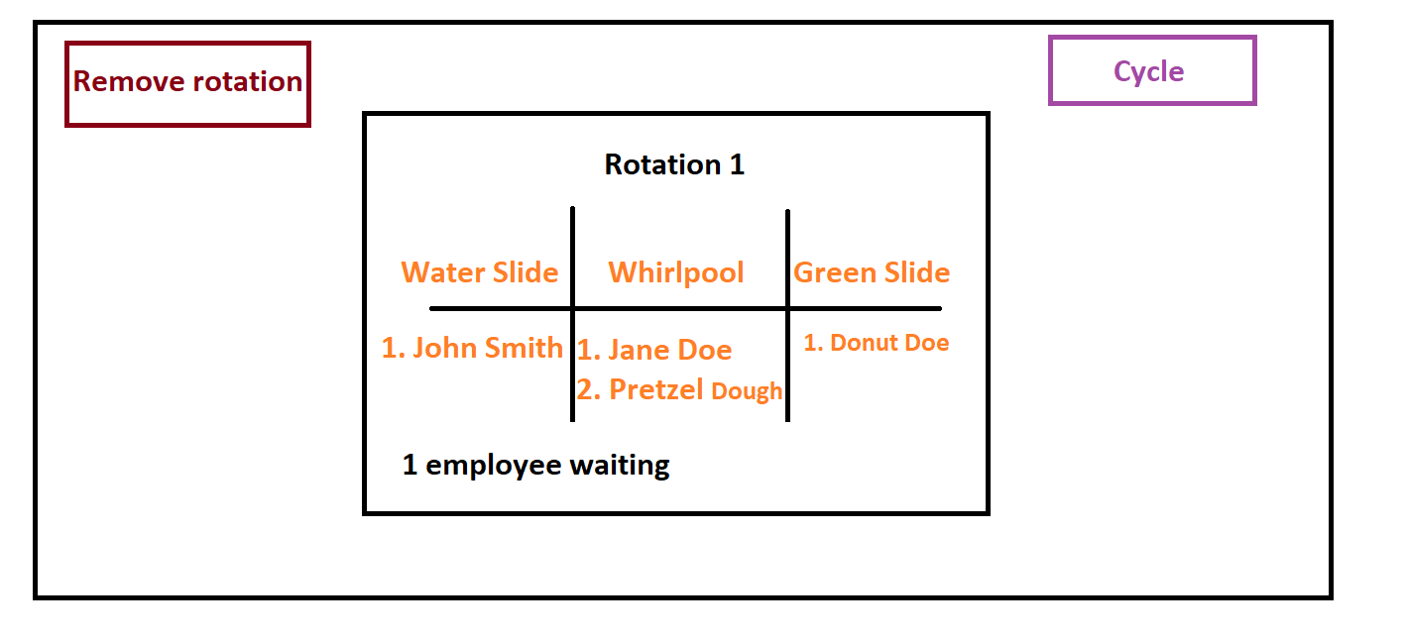

As you can see, the employees have been populated into a table with an indication that 1 user is on standby. Notice how the “Add rotation” button has been replaced by “Cycle.” Notice that we also have a “Remove rotation” button. If that is clicked, all the information we entered is wiped and we go back to this screen:



However, if we click on “cycle,” we will pull all the employees from their stations and then we will find new positions for them. How will we determine where each employee will go? See the following table:

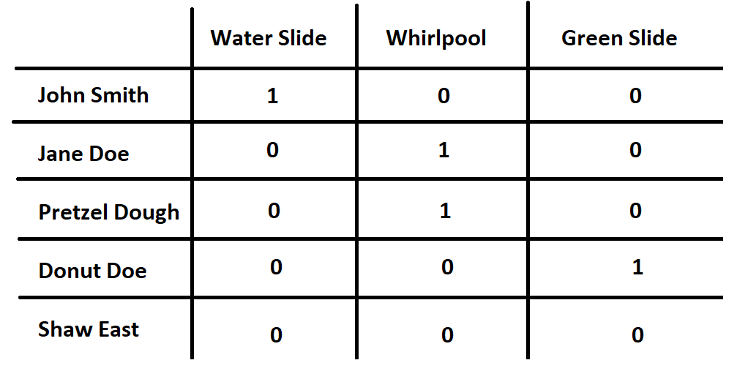

Notice that John Smith has been to the Water Slide 1 time. Jane Doe has been to the Whirlpool 1 time. Pretzel Dough has been to the Whirlpool 1 time. Donut Doe has been to the Green Slide 1 time. And finally, Shaw East hasn’t been to any of the stations because all positions were full.

The way in which we will determine where an employee will be placed is a bit like a priority queue. For each employee, we will take their largest number minus their smallest number to determine their priority.

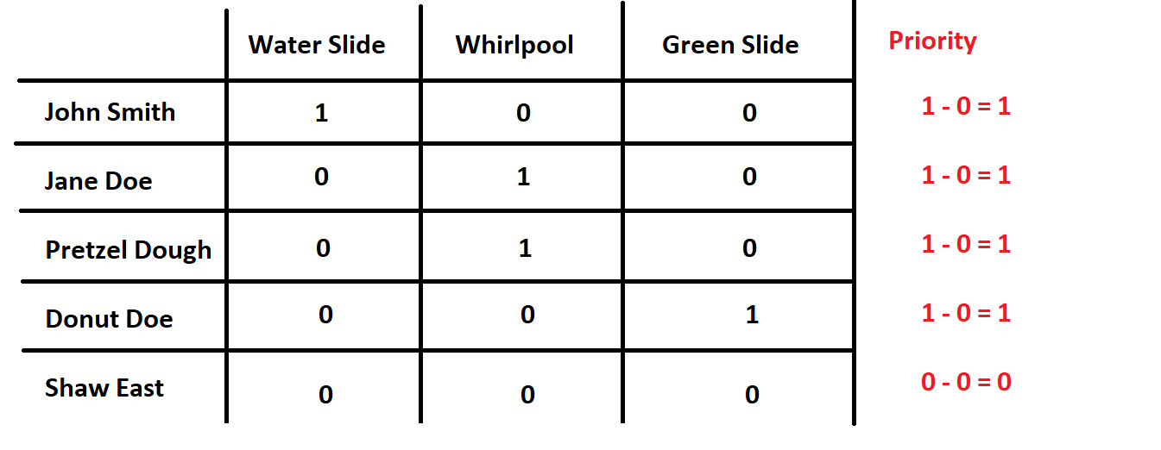

The person with the highest priority number will get placed somewhere first. The person with the lowest priority will be placed somewhere last. Here, John, Jane, Pretzel, and Donut all have the same priority so we will choose them by which station has the most people. Since Whirlpool can accommodate the most people, we will choose Jane Doe and Pretzel Dough to go first (doesn’t matter who we choose first).

Let’s pick Jane. She has been to the Whirlpool 1 time and then 0 times for Green Slide and Water Slide. We can place her in either of those two. Let’s place her at the water slide. She will now have been at Water Slide 1 time, Whirlpool 1 time, and Green Slide 1 time.

Let’s pick Pretzel Dough next. He has been at Whirlpool 1 time and then Green Slide / Water Slide 0 times. Since Jane is occupying the Water Slide and that station only accommodates 1 employee, Pretzel must go to Green Slide. He will now have gone to Whirlpool 1 time, Green Slide 1 time, and Water Slide 0 times.

Water Slide and Green Slide are tied with 1 position each so we can pick either John or Donut next. Let’s pick John. He has been to the Water Slide 1 time, Whirlpool 0 times, and Green Slide 0 times so we need to place him where he is needed the most. Water Slide is full because Jane is there. Green Slide is full because Pretzel is there. Whirlpool has 0 current employees there so John will go there.

Shaw East must remain where he is. New table will look like the following:

